K L (DEEMED TO BE) UNIVERSITY
DEPARTMENT OF COMPUTER SCIENCE AND ENGINEERING

PROJECT REPORT
ON
“MINI LINUX SHELL WITH BACKGROUND JOB MANAGEMENT”

A Project Report Submitted in partial fulfillment of the requirements for the award of the degree of
BACHELOR OF TECHNOLOGY
in
COMPUTER SCIENCE AND ENGINEERING

Submitted by
Student Name | Roll Number
P. HARINI | 2520030177
AASRITHA | 2520030178
P. BINDHU MADHAVI | 2520030077

Under the Esteemed Guidance of
Dr. K. Hema
Assistant Professor
Department of Computer Science and Engineering

Academic Year 2026–2027

DECLARATION
We hereby declare that the project report entitled “Mini Linux Shell with Background Job Management” is a record of the work carried out by P. Harini (2520030177), Aasritha (2520030178), and P. Bindhu Madhavi (2520030077), in partial fulfillment of the requirements for the award of the Bachelor of Technology degree in Computer Science and Engineering at K L (Deemed to be) University.
The report describes a menu-driven Linux shell prototype implemented in C. The work focuses on executing commands, tracking child processes, and demonstrating basic foreground and background job management using Linux/POSIX process APIs.
The project material and results described here are based on the supplied project facts, source code, Makefile, and screenshots. Features not present in the supplied C implementation are identified as possible future enhancements rather than claimed as completed functionality.

Student Name | Roll Number | Signature
P. HARINI | 2520030177
AASRITHA | 2520030178
P. BINDHU MADHAVI | 2520030077

CERTIFICATE
This is to certify that the project report entitled “Mini Linux Shell with Background Job Management” is a bonafide project report prepared by P. Harini (2520030177), Aasritha (2520030178), and P. Bindhu Madhavi (2520030077), in partial fulfillment of the requirements for the award of the Bachelor of Technology degree in Computer Science and Engineering at K L (Deemed to be) University during the academic year 2026–2027.
The project demonstrates basic operating-system concepts through a C program that creates child processes, executes Linux commands, tracks jobs, and uses signals to stop, resume, or request termination of processes.

Project Guide | Course Coordinator | Head of Department
Dr. K. Hema

ACKNOWLEDGEMENT
We express our sincere gratitude to our project guide, Dr. K. Hema, Assistant Professor, Department of Computer Science and Engineering, for the guidance and encouragement provided during the development of this project.
We thank the faculty members and department for providing the opportunity to apply Operating Systems and C programming concepts in a practical project. We also acknowledge the support of our classmates, friends, and family members during implementation, testing, and documentation.
This project helped us connect classroom concepts such as process creation, program execution, waiting for child processes, job tracking, and signal handling with practical Linux programming.
P. HARINI – 2520030177
AASRITHA – 2520030178
P. BINDHU MADHAVI – 2520030077

ABSTRACT
Mini Linux Shell with Background Job Management is a menu-driven command-line application developed in the C programming language for Linux/Ubuntu. The project provides a simplified shell interface through which users can execute commands without entering them directly into a conventional terminal prompt. It demonstrates how operating systems create processes, execute programs, wait for child processes, and manage jobs while commands run.
The application offers nine menu options: execute a command in the foreground, run a command in the background, view active jobs, bring a job to the foreground, resume a job in the background, stop a job, request termination of a job, display the current working directory, and exit. The implementation uses fork() to create a child process, execvp() to execute the requested command, waitpid() to wait for or inspect child status, getcwd() to retrieve the current directory, and kill() to send signals to a selected job.
Each tracked job is assigned a shell-level Job ID and retains the Linux process ID (PID), command text, active state, and stopped state. The distinction between Job ID and PID is important because the menu requests the Job ID for job-control actions. SIGSTOP pauses a job, SIGCONT resumes it, and SIGTERM requests its termination. The project is compiled with GCC, and a Makefile automates the build.
The supplied screenshots show a web dashboard concept for the project, including command execution and a background-jobs table. One screenshot displays a message that jobs could not be loaded and advises checking the Flask server. This web-dashboard message is not evidence that the provided C command-line program failed; the supplied C source and Makefile describe the separate command-line implementation. The project is a learning prototype and does not aim to replace a complete shell such as Bash.
Keywords: Linux, C programming, shell, process management, fork(), execvp(), waitpid(), background jobs, signals, GCC, Makefile.

TABLE OF CONTENTS
Chapter | Title | Main contents
1 | Introduction | Background, problem statement, scope, objectives, importance, users
2 | OS Concepts and Background Study | Processes, system calls, signals, foreground/background execution
3 | System Requirements | Hardware, software, operating environment, tools
4 | Technology and Tools Used | C, GCC, Make, POSIX/Linux APIs and commands
5 | System Architecture and Design | Architecture, workflow, modules, input/output design
6 | Implementation | Data structures, functions, algorithms, system calls
7 | Execution and Demonstration | Build steps, commands, test cases, supplied screenshots
8 | Conclusion and Future Enhancements | Summary, achieved objectives, limitations, learning outcomes
9 | References | Books, manual pages and official documentation

Note: Page numbers may change when the report is opened and formatted on another computer. Update the table of contents and page numbering in Word after any final edits.

CHAPTER 1 – INTRODUCTION

1.1 Background of the Project
An operating system manages the execution of programs as processes. A process has a process identifier (PID), execution state, and associated resources. When a user runs a command in Linux, the shell typically creates or controls a process to execute the program. Understanding this relationship is an important part of Operating Systems and systems programming.
A conventional shell provides a powerful command interface, but the internal mechanics of process creation, execution, waiting, and job control can be difficult for beginners to observe. This project provides a small, menu-driven environment in which the user chooses an operation and sees the corresponding process-management behaviour.

1.2 Problem Statement
Students learning operating systems need a practical way to explore how commands run as processes and how processes can be tracked or controlled. Typing commands in a normal terminal is useful, but it does not necessarily make the relationship between a shell-level job, its PID, and its execution state clear to a beginner.
The project addresses this learning need by providing a simple menu that supports foreground execution, background execution, job listing, resuming, stopping, and termination requests. It also displays the current working directory and provides a controlled exit option.

1.3 Scope of the Project
- Execute external Linux commands using a child process.
- Wait for foreground commands to finish or stop.
- Start background commands and return control to the menu immediately.
- Maintain a fixed-size table of up to 100 tracked jobs.
- Assign each tracked job a shell-level Job ID and store its PID and command.
- Display active jobs and their running/stopped status.
- Resume a job in the foreground or in the background.
- Send SIGSTOP and SIGTERM signals to selected jobs.
- Display the current working directory using getcwd().
- Build the program using GCC and a Makefile.

1.4 Objectives of the Project
- Demonstrate process creation through fork().
- Demonstrate command execution through execvp().
- Understand waiting and non-blocking status checks through waitpid().
- Explain the difference between Job ID and PID.
- Demonstrate basic signal-based job control.
- Provide a menu that makes the operations easy to test.
- Use a Makefile to simplify compilation and cleanup.

1.5 Importance of the Application
The project turns theoretical operating-system concepts into observable program behaviour. It allows learners to compare foreground and background execution, observe job-table entries, and test signals on processes started by the program. It also introduces practical C programming patterns such as structures, arrays, string tokenization, error handling, and system API calls.

1.6 Target Users / Audience
- Students studying Operating Systems and C systems programming.
- Linux beginners who want to understand child processes and signals.
- Learners practising GCC, terminal commands, and Makefiles.
- Instructors demonstrating basic process lifecycle and job-management concepts.

CHAPTER 2 – OS CONCEPTS AND BACKGROUND STUDY

2.1 Process Management
A process is a program in execution. Linux assigns a process identifier (PID) to each process. The shell stores the PID of each child it creates so that it can wait for that child or send it signals. In this project, a Job structure stores both the PID and a separate Job ID used by the menu.

2.2 fork() and Child Processes
fork() creates a child process by duplicating the calling process. The return value is negative on failure, zero in the child, and the child PID in the parent. The project checks for failure and branches into child and parent behaviour. The child resets selected signal dispositions to their defaults before executing the command.

2.3 execvp() and Command Execution
execvp() searches for the requested executable using the PATH environment and replaces the calling child process image with that program. If execvp() returns, execution has failed; the code prints an error using perror() and exits the child with status 127.

2.4 waitpid() and Process Status
waitpid() allows the parent to wait for a child or inspect its state. For foreground execution, the program waits for the selected child and uses WUNTRACED so that a stopped child can be detected. The refresh_jobs() routine uses WNOHANG, WUNTRACED, and WCONTINUED to check job status without blocking the menu.

2.5 Foreground and Background Execution
Aspect | Foreground command | Background command
Parent behaviour | Waits for the child to finish or stop | Registers the job and returns to the menu
User experience | The menu waits while the command runs | The menu is available while the command runs
Example | sleep 5 | sleep 60
Tracking | A stopped foreground child can be added as a job | The child is added to the job table immediately

2.6 Signals
Signal / API | Purpose in this project
SIGSTOP | Stops a selected job; it cannot be caught or ignored by the target process.
SIGCONT | Continues a stopped job.
SIGTERM | Requests that a job terminate; the process may handle or ignore this signal.
kill() | Sends a signal to the process identified by PID.

2.7 Existing Methods and Proposed Approach
Traditional Linux shells such as Bash provide command execution and advanced job control. This project is intentionally smaller. Rather than implementing all shell syntax, it concentrates on core process-management operations in a numbered menu. The proposed approach keeps a fixed array of Job records and refreshes their status using waitpid().

2.8 Advantages of the Proposed Approach
- A beginner-friendly menu separates operations into clear choices.
- The Job ID/PID distinction is visible in job messages.
- Foreground and background behaviour can be compared with simple commands.
- Signal operations demonstrate process control.
- The Makefile provides repeatable compilation and cleanup.

CHAPTER 3 – SYSTEM REQUIREMENTS

3.1 Hardware Requirements
Component | Suggested requirement
Processor | Any modern dual-core processor or equivalent
RAM | 2 GB minimum; 4 GB recommended for a comfortable development environment
Storage | At least 100 MB free for source files, executable and documentation
Input/output | Keyboard, display and terminal window

3.2 Software Requirements
Software | Purpose
Ubuntu / Linux | Operating environment for compiling and running the application
GCC | Compiles the C source code
GNU Make | Runs the build rules in the Makefile
Linux terminal | Accepts build commands and displays program output
Text editor / IDE | Creates and edits shell.c, shell.h and Makefile

3.3 Operating System Environment
The project is intended for Linux/Ubuntu because it uses POSIX process APIs and Linux signals. It may also be compiled in a compatible Linux environment such as Ubuntu under WSL. Behaviour and permissions depend on the environment and the commands available in PATH.

3.4 Compiler and Build Configuration
The supplied Makefile defines GCC as the compiler and uses the flags -Wall, -Wextra, and -std=c11. These options enable common warnings and select the C11 language standard. The target executable is named minishell. The clean target removes the generated executable.
CC = gcc
CFLAGS = -Wall -Wextra -std=c11
TARGET = minishell
SOURCES = shell.c
all: $(TARGET)
$(TARGET): $(SOURCES) shell.h
$(CC) $(CFLAGS) $(SOURCES) -o $(TARGET)
clean:
rm -f $(TARGET)
.PHONY: all clean
Implementation note: the provided Makefile lists shell.h as a dependency. The supplied shell.c defines its Job structure and functions internally and does not include shell.h. This dependency does not itself cause a problem if shell.h exists, but the header declarations and implementation are not currently integrated as a shared interface.

CHAPTER 4 – TECHNOLOGY AND TOOLS USED

4.1 C Programming Language
C is used because it provides direct access to operating-system interfaces and supports structured programming with functions, arrays, structures, and standard input/output. The project uses a Job structure to group related information for each tracked command.

4.2 GCC Compiler
GCC converts shell.c into the executable minishell. The warning flags help identify suspicious or non-portable code during compilation. A successful build creates a program that can be launched from the terminal.

4.3 GNU Make and Makefile
The Makefile records the build target, source file, compiler, compiler flags, and cleanup rule. Running make compiles the program when needed. Running make clean removes the compiled executable so the project can be rebuilt.

4.4 Linux / POSIX APIs Used
Function / macro | Purpose
fork() | Create a child process.
execvp() | Run the requested external command in the child process.
waitpid() | Wait for or inspect child status, including stopped and continued states.
getcwd() | Retrieve the current working directory.
chdir() | Change the working directory when the entered command is cd.
kill() | Send a signal to a process.
signal() | Set signal handling behaviour in the child before exec.
strtok() | Split the command line into whitespace-separated arguments.
snprintf() | Copy command text into a fixed-size buffer safely with a size limit.
perror() | Print a message describing the most recent system error.

4.5 Linux Commands Used for Testing
- date – displays the current date and time.
- ls – lists directory entries.
- pwd – displays the current working directory.
- whoami – displays the current user name.
- sleep 5 – provides a short foreground process test.
- sleep 60 – provides a background process test.

4.6 Other Libraries and Headers
The source includes standard headers for input/output, memory and string operations, process identifiers, process waiting, signals, and error reporting. The implementation relies on the C library and POSIX/Linux APIs and does not require third-party libraries.

CHAPTER 5 – SYSTEM ARCHITECTURE AND DESIGN

5.1 Overall System Architecture
The application uses a single-process shell program that repeatedly displays a menu and accepts a numeric choice. When a command must be run, the parent process creates a child with fork(). The child executes the command using execvp(). The parent either waits for the child (foreground) or records it as a background job and returns to the menu.
User
|
v
Menu and input validation
|
+--> Foreground command --> fork() --> child: execvp()
| parent: waitpid()
|
+--> Background command --> fork() --> child: execvp()
| parent: add_job()
|
+--> Job table / refresh_jobs() / list_jobs()
|
+--> Resume, stop, terminate --> kill() + signal
|
+--> Current directory --> getcwd()

5.2 System Workflow
- Display the welcome message.
- Refresh the status of tracked jobs.
- Display the nine-option menu.
- Read and validate the menu selection.
- For command execution, read the command string and split it into arguments.
- Handle cd internally using chdir(); otherwise create a child with fork().
- In the child, call execvp() to run the requested program.
- In foreground mode, wait for the child; in background mode, record its Job ID and PID.
- For job operations, locate the job by Job ID and use waitpid() or kill() as required.
- Repeat until the user selects Exit or input reaches end-of-file.

5.3 Job Data Structure
typedef struct {
int id; /* shell-level Job ID */
pid_t pid; /* Linux process ID */
char command[MAX_CMD]; /* original command text */
int active; /* whether the table entry is in use */
int stopped; /* whether the job is marked stopped */
} Job;
The jobs array contains up to MAX_JOBS (100) entries. next_id assigns increasing job identifiers. A job is found by matching the requested ID against active entries. When a process is detected as finished or signalled, the entry is marked inactive so its slot can be reused.

5.4 Module Description
Module | Description
Menu handling | Displays the nine operations and reads the user choice.
Command parser | Reads a command, removes the newline, saves a copy, and tokenizes it by spaces and tabs.
Command execution | Uses fork() and execvp() for external commands; handles cd with chdir().
Job registration | Adds a child process to the job table with Job ID, PID and command.
Job refresh and listing | Uses waitpid() flags to update state and print active jobs.
Job resume | Sends SIGCONT and optionally waits for the job in foreground mode.
Signal control | Sends SIGSTOP or SIGTERM to the chosen job.
Directory display | Uses getcwd() to display the current directory.
Build automation | Uses Makefile rules to compile and clean the executable.

5.5 Input and Output Design
Option | Operation | Input | Expected behaviour
1 | Execute command (foreground) | Command text | Runs the command and waits for completion or stop.
2 | Run command in background | Command text | Registers the job and returns to the menu.
3 | View all jobs | None | Shows active Job ID, status, PID and command.
4 | Bring job to foreground | Job ID | Continues the job and waits for it.
5 | Resume job in background | Job ID | Continues the job and returns to the menu.
6 | Stop a job | Job ID | Sends SIGSTOP.
7 | Terminate a job | Job ID | Sends SIGTERM as a termination request.
8 | Show current directory | None | Prints the current working directory.
9 | Exit | None | Displays exit message and terminates the shell.

CHAPTER 6 – IMPLEMENTATION

6.1 Main Program Structure
The main() function prints a welcome message and enters a loop. At the beginning of each loop iteration, refresh_jobs() checks tracked children. The menu is displayed and scanf() reads the choice. Invalid non-numeric input is cleared from the input buffer and a warning is printed. The switch statement dispatches the selected operation.

6.2 Command Parsing and Execution
run_command() reads a line into a fixed-size buffer and removes its newline. It saves a copy of the command for job reporting, then uses strtok() to split the text on spaces and tabs. The resulting argument array ends with a NULL pointer as required by execvp(). This simple parser does not support shell quoting, pipes, redirection, wildcard expansion, or variable expansion.

6.3 Foreground Execution Algorithm
- Prompt the user for a command.
- Tokenize the command into the executable name and arguments.
- If the command is cd, call chdir() and return.
- Call fork() and handle a failure if the return value is negative.
- In the child process, reset selected signals to defaults and call execvp().
- In the parent process, wait with waitpid() and WUNTRACED.
- If the child stops, add it to the job table as a stopped job.

6.4 Background Execution Algorithm
- Read and tokenize the command.
- Create a child process using fork().
- The child calls execvp() to execute the requested program.
- The parent does not wait for normal completion at this point.
- The parent calls add_job() to store the PID and command.
- The menu is displayed again while the child continues running.

6.5 Job Refresh and Listing
refresh_jobs() loops through active entries and calls waitpid() with WNOHANG, WUNTRACED, and WCONTINUED. WNOHANG avoids blocking the menu when the process has not changed state. WUNTRACED reports stopped children, while WCONTINUED reports children that have resumed. Completed or signalled jobs are marked inactive. list_jobs() first refreshes the entries and then prints the active job records.

6.6 Resume and Signal Operations
resume_job() requests a Job ID, searches for the active entry, and sends SIGCONT. If the user selected foreground mode, the function waits for the child and checks whether it stopped again or finished. Otherwise, it prints a background-resumed message. signal_job() locates a job and sends the requested signal, either SIGSTOP or SIGTERM, then prints a status message.

6.7 Current Working Directory and cd
Option 8 calls getcwd() with a 1024-byte buffer and prints the returned path. The cd command is handled inside the shell process using chdir(), rather than being launched as a child. This is necessary because changing directory in a child process would not change the working directory of the parent shell.

6.8 Error Handling
- fork() failure is reported using perror().
- A failed execvp() prints “Command failed” with the operating-system error and exits the child with status 127.
- A failed chdir() reports the error using perror().
- Invalid menu input and invalid Job ID input are handled with messages.
- If a requested Job ID is not active, the program reports “Job not found.”
- A full job table produces the message “Job table full.”

6.9 Important Implementation Notes
The program tracks direct child processes created by this shell. A termination request is not the same as confirmed process completion; the job is marked inactive when waitpid() reports completion or a later refresh discovers that the child is no longer waitable. The implementation uses a fixed-size job table and simple whitespace tokenization.
The supplied shell.h declares a Job structure and several function prototypes, but the provided shell.c defines a different command-size macro and implements several functions as static functions. The header is listed as a Makefile dependency but is not included by shell.c. For a clean maintainable project, the header and implementation should be aligned in a future revision.

CHAPTER 7 – EXECUTION AND DEMONSTRATION

7.1 Compilation in Ubuntu
Place shell.c, shell.h, and Makefile in the same project directory. Open Ubuntu Terminal and change to that directory.
cd ~/mini-linux-shell
make
If the build succeeds, the executable named minishell is created. If make reports that no Makefile exists, verify that the file is named exactly Makefile (capital M, no extension). If compiler warnings appear, review them before the demonstration.

7.2 Execution Commands
./minishell
To remove the executable and rebuild later, use:
make clean
make

7.3 Suggested Test Cases
Test | Steps | Expected result
Current directory | Choose option 8 | Prints the current working directory.
Foreground command | Choose 1, enter pwd | Prints the path and returns to the menu after the command completes.
Date command | Choose 1, enter date | Displays date/time output and returns to the menu.
Background command | Choose 2, enter sleep 60 | Prints a Job ID and PID; the menu returns immediately.
List jobs | Choose 3 | Shows active job ID, PID, command and running/stopped state.
Stop a job | Choose 6 and enter the Job ID | Sends SIGSTOP and prints a stopped message if the signal request succeeds.
Resume in background | Choose 5 and enter the Job ID | Sends SIGCONT and returns to the menu.
Bring to foreground | Choose 4 and enter the Job ID | Continues the job and waits for its next state change/completion.
Terminate request | Choose 7 and enter the Job ID | Sends SIGTERM and prints a termination-request message.
Exit | Choose 9 | Prints the exit message and terminates the program.

7.4 Sample Terminal Session
Welcome to Mini Linux Shell!
========== MINI LINUX SHELL ==========
1. Execute command (foreground)
2. Run command in background
3. View all jobs
4. Bring job to foreground
5. Resume job in background
6. Stop a job
7. Terminate a job
8. Show current directory
9. Exit
======================================
Enter choice: 2
Enter command: sleep 60
Job [1] added. PID: 6640
The PID above is illustrative, not a fixed result. Linux assigns PIDs dynamically, so actual values differ between runs. The Job ID is assigned by the program and should be entered for menu operations that ask for a job ID.

7.5 Supplied Screenshot – Dashboard View
The following supplied screenshot shows the Mini Linux Shell web-dashboard concept. It includes a current-working-directory panel, a command input field, foreground/background buttons, command output, and a background-jobs table.
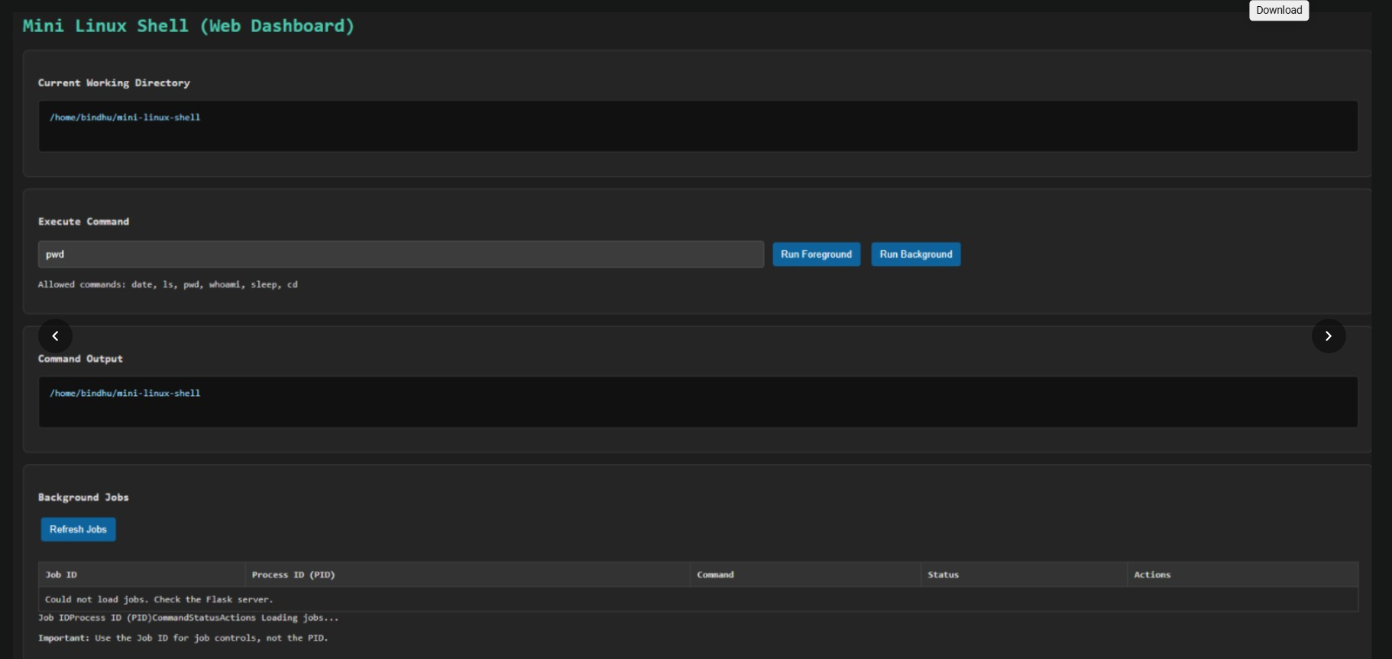
Figure 7.1 – Mini Linux Shell web dashboard and command output
The screenshot also displays “Could not load jobs. Check the Flask server.” This indicates that the dashboard could not retrieve job data from its expected Flask backend at the time of capture. It should be described as a dashboard/backend integration issue, not as a verified output of the supplied standalone C source.

7.6 Supplied Screenshot – Menu and OS Concepts
The second supplied screenshot documents the nine menu options and lists the operating-system functions associated with process creation, program execution, waiting, stopping, continuing, and termination.
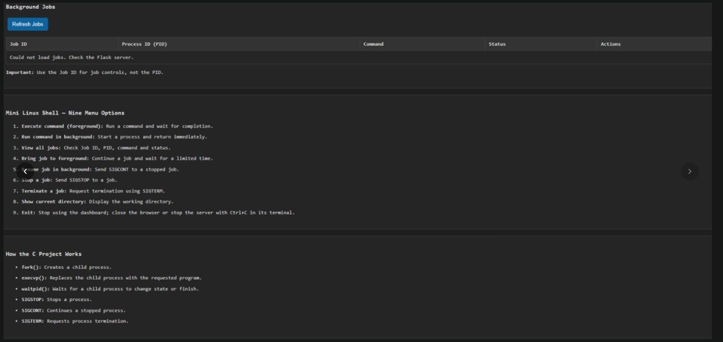
Figure 7.2 – Nine menu options and core process-management concepts

7.7 Demonstration of OS Concepts
Concept | Where it is demonstrated
Process creation | fork() inside run_command().
Program replacement | execvp() in the child process.
Waiting for child | waitpid() in foreground execution and job refresh.
Non-blocking check | WNOHANG in refresh_jobs().
Stopped process status | WUNTRACED and SIGSTOP.
Resuming a process | SIGCONT in resume_job().
Termination request | SIGTERM in signal_job().
Working directory | getcwd() and chdir().
Job tracking | Job structure, add_job(), find_job(), list_jobs().

CHAPTER 8 – CONCLUSION AND FUTURE ENHANCEMENTS

8.1 Summary of the Project
Mini Linux Shell with Background Job Management is a C-based educational shell for Linux/Ubuntu. It provides a menu for running commands in the foreground or background, listing jobs, resuming jobs, stopping jobs, requesting termination, and showing the current working directory. The core implementation demonstrates fork(), execvp(), waitpid(), getcwd(), chdir(), kill(), and signal handling.

8.2 Objectives Achieved
- Created a menu-driven interface with nine operations.
- Implemented child-process creation and external command execution.
- Implemented foreground waiting and background job registration.
- Maintained job records with a Job ID, PID, command and state flags.
- Implemented job listing and status refresh.
- Implemented resume, stop, and termination-request operations using signals.
- Added current-directory display and internal cd handling.
- Provided a Makefile for build and clean operations.

8.3 Results Achieved
The supplied source code provides the logic for the nine menu options and uses Linux/POSIX APIs to demonstrate basic job management. The project facts supplied with the request report testing of date, ls, pwd, whoami, sleep 5, and sleep 60; a job listing with Job ID, PID, and running status; a stop message; and a termination-request message. A termination-request message alone does not prove that a process has fully exited.

8.4 Limitations
- This is a learning prototype, not a full replacement for Bash.
- The parser splits commands on spaces and tabs and does not implement quoting, pipes, redirection, command substitution, or variable expansion.
- Job tracking is limited to a fixed array of 100 entries.
- The implementation does not implement full process-group and terminal-control behaviour of an interactive shell.
- SIGTERM requests termination but does not guarantee immediate exit.
- The supplied web dashboard screenshot shows a Flask job-loading issue; the provided C program and Makefile do not themselves implement a Flask backend.
- The supplied shell.h declarations should be aligned with shell.c for maintainability.

8.5 Future Enhancements
- Add support for quoted arguments and more robust command parsing.
- Implement pipelines and input/output redirection.
- Improve process-group and terminal foreground control.
- Handle child-process events and job-table updates more comprehensively.
- Align shell.h and shell.c so shared declarations are defined once.
- Add automated test cases for job completion, stopping, resuming, and invalid input.
- If the web dashboard is part of the final deliverable, implement and test a Flask API that safely communicates with the shell and displays real job data.
- Improve job table output with clearer columns and explicit completed/stopped states.

8.6 Skills and Learning Outcomes
- Understanding Linux process creation and program execution.
- Using waitpid() to observe child-process state changes.
- Using signals to control processes.
- Working with C structures, arrays, strings and error handling.
- Compiling C programs with GCC and automating builds with Make.
- Testing foreground and background behaviour in Ubuntu.
- Documenting implementation scope, test results, and limitations accurately.

CHAPTER 9 – REFERENCES

9.1 Books
- A. Silberschatz, P. B. Galvin, and G. Gagne, Operating System Concepts, Wiley.
- W. Richard Stevens and Stephen A. Rago, Advanced Programming in the UNIX Environment, Addison-Wesley.
- Brian W. Kernighan and Dennis M. Ritchie, The C Programming Language, Prentice Hall.

9.2 Linux and POSIX Documentation
- Linux manual page: fork(2).
- Linux manual page: exec(3) / execvp().
- Linux manual page: waitpid(2).
- Linux manual page: kill(2).
- Linux manual page: signal(7).
- Linux manual page: getcwd(3) and chdir(2).

9.3 Compiler and Build Documentation
- GNU Compiler Collection (GCC) documentation.
- GNU Make Manual.

9.4 Online Resources
Linux manual pages: https://man7.org/linux/man-pages/
GNU Compiler Collection: https://gcc.gnu.org/onlinedocs/
GNU Make Manual: https://www.gnu.org/software/make/manual/
These references provide background for the APIs and build tools used by the project. The implementation-specific descriptions in this report are based on the supplied source code and project facts.

